 The Circle

2022-23 VSC President’s Newsletter .August 2022 Issue

DATES TO REMEMBER:

- September 24 – VSC Leadership Conference, Best Western, Waynesboro, VA

- September 25 – VSC Fall Board Meeting, Best Western, Waynesboro, VA

- October 1 – VSC Chapter Dues (first half) due - $11.00 per chapter member; make checks payable to VSC ESA and give/mail them to Stephanie Hess

- November 4-5 – SERC Conference, Renaissance Orlando Airport Hotel, Orlando, FL

- March 25, 2023 – VSC Spring Board Meeting, Vision of Hope United Methodist Church, Harrisonburg, VA

- May 19-21, 2023 – VSC Convention, The Hotel Madison, Harrisonburg, VA

From the President …

I came across the following representation of what we can and cannot control and I think I need to print it out and put it on my desk beside my computer or make it my cellphone wallpaper.

WHAT ABOUT YOU? Do you sometimes poke outside of your circle of control, thinking that you can influence one of the outlying areas? Something to think about! I know that sometimes my need for control is at odds with my need to just walk away!

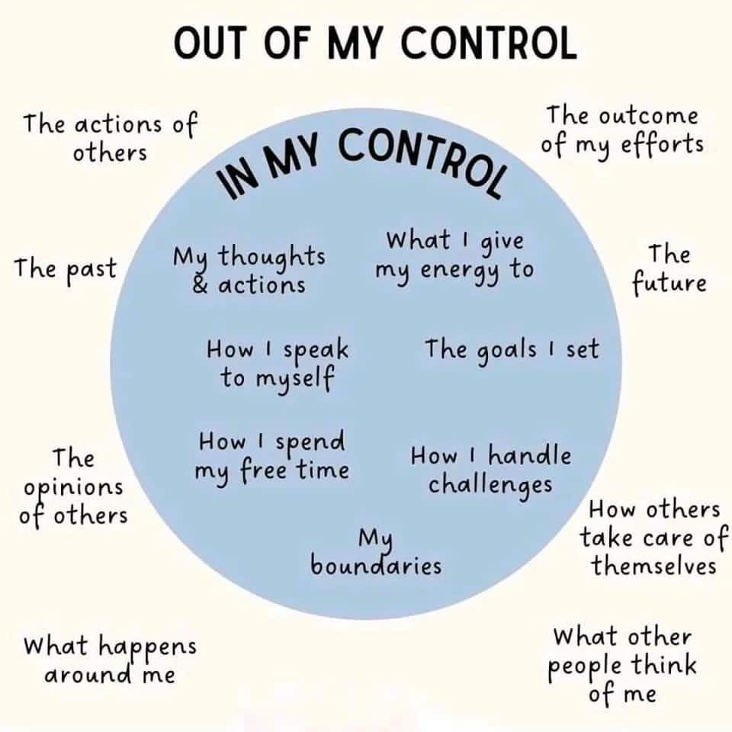

IC Convention – Indianapolis

Well, what can I say! First, the positive - The Lip-Sync competition (IC fundraiser) was a hoot! We thought we had an original idea with the singing nuns; however, it just goes to show you that ESA sisters think alike – there were 3 other groups of singing sisters! We didn’t win but did have a lot of fun and with 18 acts, the evening was a great event.

The Mixer Party was well planned – food was good and there were 6 game stations with simple challenges. I was the only one who played from Virginia and I did have fun and an idea to bring back for a future Virginia event.

It was an honor representing Virginia at IC. I am always touched by the flag ceremony and seeing everyone dressed in red, white, and blue. There was a sadness due to the passing of IC President, Robin Bussey; however, the tributes and memories that were shared kept her presence with us throughout the week.

I did have the privilege of picking up a couple of awards for Virginia, which will be shared at the VSC Fall Board Meeting so if you want to know what they were – BE THERE!

Our ‘guest’ speaker was none other than BJ Clark! That lady is a walking miracle having not only survived ovarian cancer but continues to thrive as a motivational dervish! She was just as up-lifting, just as inspiring, just as humorous as she has always been and when she is done speaking – you walk away with a smile on your face and in your heart! What a gift to ESA!
Denise Holdaway’s installation on Saturday evening was lovely and fun, as you would expect nothing else from her installing officers, Charlotte Garrett and Judy Thomlinson.

Again, I was honored to carry that small cardboard placard with Virginia’s donation to St. Jude on Saturday evening. Our state donation was not as large as others have been in the past; however, with it representing a COVID period, I was extremely proud. I will share our number with Susan Caldwell, along with ESA’s 2021-22 total and our 50-year total. If you want to know what they are – COME TO THE FALL MEETING!

Also, a happy accidental find during our visit was a local restaurant called, Steer-In. Believe me it was nothing to look at and honestly I thought it resembled a vacated Sonic drive in on the outside. BUT…. This was an example where the cover did not reveal the inside of the book. THE FOOD WAS OUTSTANDING! Nothing fancy, local clientele, but the very best onion rings I have ever had AND we even went back there for our ‘state’ dinner on Friday evening. We found out that in fact the Steer-In had been featured on Diners, Drive-Ins, and Dives back in 2012 (I think). It was a hit and having a Starbucks within a quarter mile of the hotel was also a huge plus!

Now for the challenges we encountered along the way! I mention these because they just made the good times even better.

First, the B-mobile left Staunton on Tuesday morning, with Mindy and Marie having left Richmond on Monday. Brenda Bowersox started feeling chilly and yucky (no other words for it) after our lunch stop. By the time we made it to the hotel, it was deemed prudent to go get a couple COVID Rapid Tests (just in case). Brenda went directly to her room (which she shared with Bev Scott) and long-story-short – did not emerge until Saturday afternoon! Yes – COVID found a way to derail our plans. As the week progressed, Brenda Orebaugh and I started feeling yucky as well. Rapid test results were negative; however, Brenda O. had a PCR test on Monday and I had one on Tuesday and they were both positive. There were others, that we know of from other states, who unfortunately came down with COVID while at IC as well with most obviously having been infected and asymptomatic before coming and some bringing the virus home with them.

I haven’t heard of any serious symptoms so am hoping all were mild like ours.

Mother nature was not about to let COVID be our only challenge – with all the rain coming out of Kentucky and passing through we ran into a monsoon both going and coming and were all praying to see sunshine once more! Unfortunately, Brenda B. was driving during both storms and she had my eternal gratitude.

You have to take the good with the bad and the friendship, laughter, and yes, some tears, will be a highlight of this trip for me to remember.

Beverley

From the ESA for St. Jude Coordinator …

Wow! You may have seen the St. Jude Monies Reveal for Virginia, ESA for 2021-22, and ESA life-time total on Facebook which was held during the IC Convention in Indianapolis. Awesome amounts!! I’ll be sharing those numbers and an explanation at the Fall VSC meeting.

ESA $50 FOR 50 PROJECT
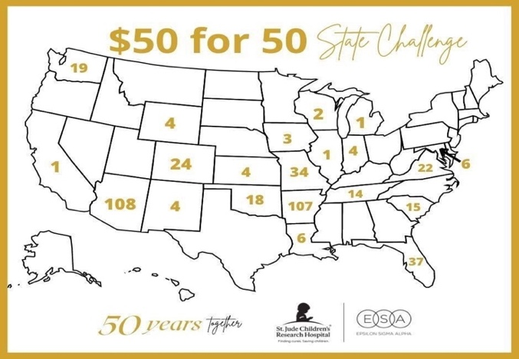

The VSC is doing a great job in the ESA $50 for 50 projects!! The project does not end until the end of 2022 so there is plenty of time to work on individual and chapter projects. Several members have notified me of on-going projects and projects just completed.

REMINDER FOR CHAPTER PHILANTHROPIC DIRECTORS
Please when you email your monthly philanthropic reporting forms to the VSC Philanthropic Director copy me on the email so that I can track your St. Jude Projects.
Email to
susancaldwellva@comcast.net

ST. JUDE WALK RUN—The 2022 event combines the Richmond and Hampton Roads events and will take place in Williamsburg.

Follow the link below to register your team or yourself.

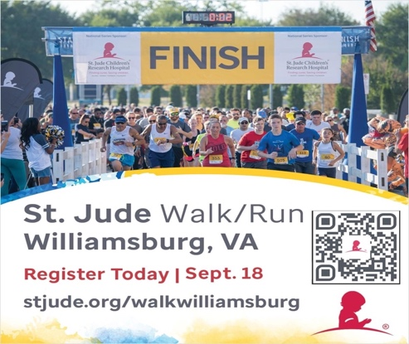

Susan Caldwell

Some additional information concerning the St. Jude Walk/Run from Lou Ann Wyer …

St Jude Walk
September 18th
Colonial Williamsburg

The 2022 St Jude Walk will be on September 18th in Williamsburg, VA for the Richmond and Hampton Roads areas this year

If you are interested in walking with us, register at our ESA Beta Kappa page: https://fundraising.stjude.org/site/TR/Walk/Walk?team_id=276159&pg=team&fr_id=137451

If you are interested in donating, you can use the same link.

If you are interested in volunteering at the Walk on Sept 17th or 18th, let me know. I can get us a call/zoom with ALSAC for our options.
Thanks
Lou Ann Wyer
l.wyer@cox.net

From the VSC PPA Leadership Chairman …

My mail box is starting to have happy mail. Registrations for Leadership are arriving. So, here is a little more info:

Leadership Registration: 9:00 AM
Leadership Starts: 10:00 AM
Lunch: 12:30 PM
(about)
Leadership Resumes: 1:15 PM
Leadership Ends: 3:30 PM
PPA Meeting: 3:45 PM
BBQ Dinner: 6:00 PM

If your significant other is traveling with you, they are also invited to the dinner. Remember bring your $20.00 per person with you. Cash and checks accepted.

I will keep you posted with any additional information as it becomes available. The registration form is attached once again.

Brenda Bowersox

Registration form and flyer attached.

From SERC Treasurer, Lauren Ryan…

We have received SERC State Dues and Virginia is in good standing. We have received Chapter Donations from Delta Rho, Beta Sigma, and Bea Kappa. We are so grateful for these donations as they help our Council to continue our important works. Please encourage Chapters to make donations.

Lauren Ryan, 202 Chateau Pl, Chapel Hill, NC 27516.



August 2 – P-Nut Schools, Beta Sigma
August 9 – Gaynell Krista, Beta Delta
August 14 – Nancy Ward, Beta Kappa
August 17 – Mike Smith, Delta Sigma
August 20 – Lynne Rightmyer, Beta Sigma
August 21 – Jane Harris, Beta Omicron
August 22 – Roxanna Leonard, Delta Rho
August 29 – Dot Harcum, Alpha Nu

Birthstones: Peridot
Birth Flowers: Gladiolus and Poppy
Attributes: Self-motivated, love their personal space, find it difficult to share their feelings face to face, stubborn in nature, hate wasting money, good at teaching.

Circle of Grace

If something or someone has come into your life for which you are very thankful, or you see God’s grace in action - let others know about it.

God’s grace was certainly surrounding us on our trip to Indianapolis and in caring for all who contacted COVID. We give thanks!

Beverley

Health Corner

More veggies and fruit have shown up in my diet in July (even at IC). I’m making a conscious effort to cut more and more carbs but I know I just can’t go carb-free like I did a couple of years ago. It is just not sustainable for me! I guess that my will-power is weakening along with my bladder and knees!

OOPS….CORRECTIONS

- Please correct the Alpha Delta chapter president on the listing I sent with the July Circle – should be Sue Danielson, 12231 River Rd., Chesterfield, VA 23838, 804-363-4852 (cell).

INSIDE THE CIRCLE
(Before the next VSC Meeting comes ‘ROUND)

- IC Council dues are due at the beginning of the ESA Year (AUGUST 1st) and must be paid before May 1st to be considered in “good standing” and receive voting privileges at IC Convention. These dues are mailed to the current IC Treasurer.

NOTE: The 2022-23 IC Treasurer is Celeste Webb, 1120 Richmond Avenue, Mattoon, IL 61938. (As of today the IC Dues Form for 2022-23 has not been added to the IC Website.)

- DEADLINE – SEPTEMBER 10 – Articles for the Fall issue of the LAMPLIGHTER to Theresa Morris.

- DEADLINE – SEPTEMBER 17 - Send copies of reports to be given at the VSC Fall Council Meeting to me:

Beverley Wright (bmwright@comcast.net)
and Katrina Saunders
VSC Recording Secretary (cookekc1964@gmail.com).

If you are an elected officer or appointed/special committee and will NOT be in attendance or will NOT be giving a report at that time, please drop me an email by September 17 as well so I can prepare the agenda accordingly. Thanks.

- LUCKY NUMBERS CONTRIBUTIONS FOR THE VSC FALL COUNCIL MEETING!
The Finance Committee has come up with the theme “Lucky Numbers Craft Fair” for the VSC Fall Leadership donations. So each chapter bring something you made or something someone else made for the ways & means event.
Note from President: If no one from your chapter will be in attendance, please consider sending something by another chapter. Right now this, along with dues, is the only money making project supporting the Virginia State Council and your help would be greatly appreciated.

SHOUT OUT FROM IC TO DEBBIE LANGFIT AND LOU ANN WYER ….

Phyllis Davis from Utah made a special effort to ask me to say hello to Debbie and Lou Ann. She met them on the bus going to the State Presidents’ Leadership Conference several years ago and she said that their kindness and friendliness made an impression on her. (We knew they were kind and friendly all along didn’t we sisters?). She was a real sweet lady and I in turn enjoyed meeting and talking with her.

SIX LITTLE STORIES WITH LOTS OF MEANING

- Once all the villagers decided to pray for rain. On the day of prayer, all the people gathered, but only one boy came with an umbrella.
THAT IS FAITH!

- When you throw babies in the air, they laugh because they know you will catch them.
THAT IS TRUST!

- Every night we go to bed without any assurance of being alive the next morning, but still we set the alarms to wake up.
THAT IS HOPE!

- We plan big things for tomorrow in spite of zero knowledge of the future.
THAT IS CONFIDENCE!

- We see the world suffering, but still, we get married and have children.
THAT IS LOVE!

- On an old man’s shirt was written a sentence, “I am not 80 years old; I am sweet 16 with 64 years of experience.”
THAT IS ATTITUDE!

HAVE A HAPPY DAY AND LIVE YOUR LIFE LIKE THESE SIX STORIES. REMEMBER – GOOD FRIENDS ARE THE RARE JEWELS OF LIFE– DIFFICULT TO FIND AND IMPOSSIBLE TO REPLACE!!

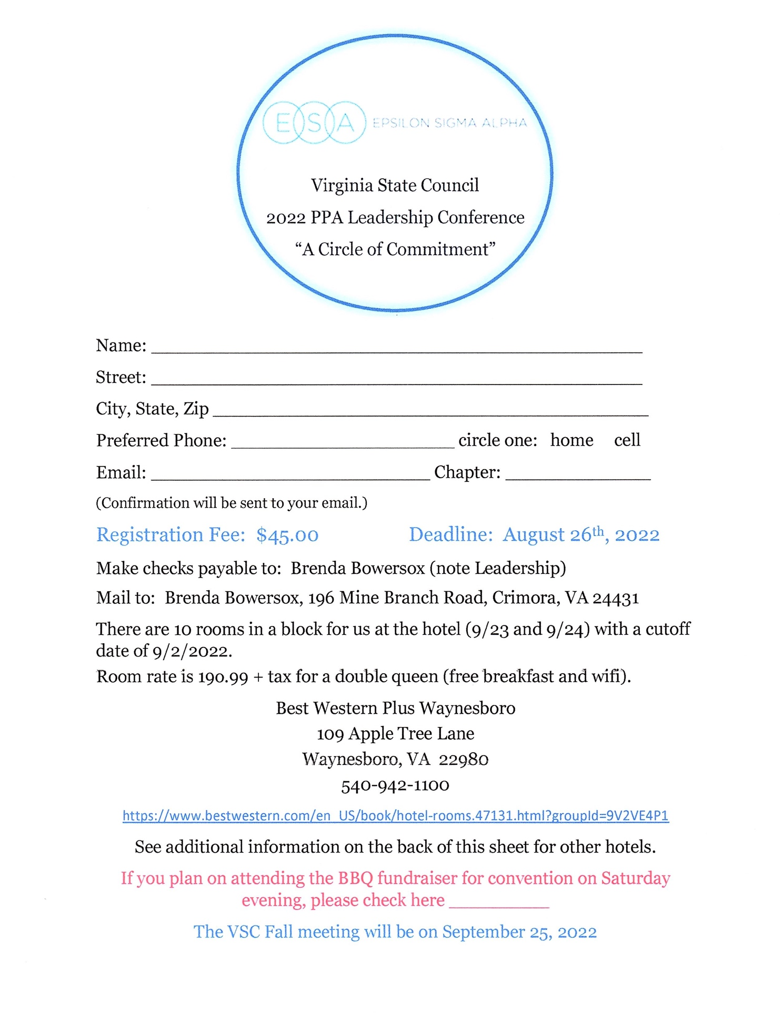

These room rates are as found on the individual hotels website for that weekend. They could change at any time.

Holiday Inn Express – Room Rate $243.00

https://www.ihg.com/holidayinnexpress/hotels/us/en/waynesboro/waybr/hoteldetail?cm_mmc=BingMaps-_-EX-_-US-_-WAYBR

Comfort Inn – Room Rate $200.00

https://www.choicehotels.com/virginia/waynesboro/comfort-innhotels/va376

Days Inn – Room Rate $124.99

https://www.wyndhamhotels.com/days-inn/waynesboro-virginia/days-innwaynesboro-va/overview

Super 8 – Room Rate $99.99

https://www.wyndhamhotels.com/super-8/waynesboro-virginia/super-8waynesboro/overview


