The Circle

2022-23 VSC President’s Newsletter July 2022 Issue

DATES TO REMEMBER:
- July 25-31 – IC Convention – Indianapolis Marriott East, Indianapolis, IN

- September 24 – VSC Leadership Conference, Best Western, Waynesboro, VA

- September 25 – VSC Fall Board Meeting, Best Western, Waynesboro, VA

- November 4-5 – SERC Conference, Renaissance Orlando Airport Hotel, Orlando, FL

- March 25, 2023 – VSC Spring Board Meeting, Vision of Hope United Methodist Church, Harrisonburg, VA (CONFIRMED)

- May 19-21, 2023 – VSC Convention, The Hotel Madison, Harrisonburg, VA

From the President …

I hope everyone had a safe and Happy July 4th! We were very ‘low-key’ this year. My son, daughter-in-law, and grands came over for a mid-afternoon picnic and then we watched fireworks later in the evening!

For those of you who were familiar with the Happy Birthday USA concerts of the past in Staunton, which were sponsored by the Statler Brothers, you will be happy to know that the tradition is continuing with “Wilson Fairchild” (Wil and Langdon Reid – sons of Harold and Don Reid) and the Jack Reid Band (Jack and Davis Reid – Wil and Langdon’s sons). This year they invited Rhonda Vincent as their guest and there were several thousand people over ‘in the park’ for all the music and festivities. Who knows – this might morph into another huge annual event that provided opportunities for local non-profit organizations to setup booths and raise money for their philanthropic projects.

Thanks to those who sent in information to be shared in this issue and I encourage everyone to continue to do the same.

Brenda Orebaugh and I are working on the VSC Yearbook this Summer and I am happy to say it is coming along nicely. I hope that after I get the new officers/roster from IC at the end of the month, we will be able to send out the VSC Yearbook in August.

Beverley

From the 2nd Vice President –

We, as ESA members, all want our organization to flourish. We have heard for years how important membership is and that has not has not changed. Virginia has lost so many members recently and, if we are to survive, we need to find new members with fresh ideas and energy. We also have many
MALs who we would love to have back as part of our chapters. Put on your thinking caps and find that special person with whom you would like to share ESA or renew their interest. Plan your events in the coming months to include them in and show them what we do and how much we enjoy doing what we do.

Marie LaDuke

From the VSC PPA Leadership Chairman …

Plans are coming right along for our Leadership in September. We hope that many of you are planning on attending. The registration form and a flyer from the hotel is included in this edition of Beverley’s newsletter.

I’ve added a line at the bottom of the registration form to let us know if you are planning on attending the BBQ fundraiser for convention on Saturday evening. If you have a form from convention in May without the line just make a note at the bottom that you are attending. The price of the meal will be $20.00 and includes pulled pork BBQ, bunches of sides, desserts and water/tea (all homemade). We will accept cash and checks for the meal at that time, please DO NOT add to your registration cost and send early.

There is also a list of additional hotels within a half mile with their rates and websites if you
choose to book from them. If you choose to come on Friday evening there are numerous
places to eat; Cracker Barrel, Panera Bread, The Fishin’ Pig (MMMM), Golden Corral, Applebee’s and Los Poncho’s, etc. We will have more information for you in early August so please stay tuned. Registration deadline and hotel deadline are August 26th so start making your plans to attend.

Brenda Bowersox

Registration form and flyer attached.

From IC State President’s Chair, Senior…

Greetings All﻿,
First of all, let me apologize for sending this out to all of you at once but I wanted to make sure the information got out.

Rozanne Robertson wanted to remind each of you to bring to Indianapolis some historical document or picture or keepsake from any of our past 75 conventions from your State. This material will be placed in a "Time capsule" to be sealed at this convention and to be opened during the 85th IC Convention.

If you have any questions feel free to reach out to her at 317-899-0846 or by email at: rozanneesa910@gmail.com

Remember that I am here for all of you.

Take care and Be Well

Patti Gale
This was the first I had heard about this request; however, if anyone has anything from an IC Convention they attended please let me know and we will make arrangements to get it to someone going to IC.
Beverley

Selling Circle

- Alpha Nu Chapter is selling raffle tickets for a beautiful table runner. The runner is hand made by Dot Harcum and proceeds will benefit St. Jude Children’s Research Hospital. One (1) ticket for $1 and six (6) tickets for $5. See attachment for additional information.

Circle of Grace

If something or someone has come into your life for which you are very thankful, or you see God’s grace in action - let others know about it.

I am eternally grateful that God accompanied my son, daughter-in-law, and grands on their recent vacation to Hilo and the Big Island, Hawaii. All of their flights were on time and they had the most wonderful experience - bringing back lots of pictures to share with us. Beverley Wright

I know I was so sorry to hear of the passing of IC President, Robin Bussey. Thanks, Lou Ann, for sending the information and Robin really did service her short time as IC President with grace and dignity in spite of her failing health. Soar High!

So many thanks to my son and grandson for bringing over a portable generator and the workers at Dominion Power for restoring service. We lost power on Wednesday at 3:30 p.m. and finally got it back on Thursday morning at 9:00 a.m.
Beverley Wright

Birthday Blessings



July 12 – Linda Rudger, Beta Kappa
July 18 – Edna Plancon, Beta Tau
July 19 – Betty Hess, Alpha Omega
July 19 – Susan Caldwell, Beta Sigma
July 19 – Alice Hudson, Delta Rho
July 20 – Nicole Blankenbeckler, Beta Sigma
July 21 – Tricia LeBlanc, Beta Kappa
July 23 – Katie Wheeling, Alpha Nu
July 29 – Theresa Morris, Alpha Nu
July 31 – Doris Hood, Beta Tau
July 31 – Jo Reedy, Sigma Chi

Birthstones: Ruby
Birth Flowers: Larkspur and Water Lily
Attributes: Very understanding, smart, helpful, calm-minded, small things matter to them, overly protective, family oriented, and they remember everything.

Health Corner

Well, how did I do on my strength training in June? Not too good. I was doing okay until I got hit with the stomach/intestinal bug and basically did not leave the sofa or bed for a week. It was not pretty! So now that it is July, I’m going to introduce something else to boost good health.

I cut out sodas/soft drinks back in 2019 and have not had any since that time. I try to limit processed sugars but do indulge in one piece of dark chocolate every day and dessert on special occasions. I know I need to eat many more fruits and vegetables EVERY day not just when the mood hits me and since summertime is the time these are at their best, so I’m going to really try to increase these every day. I just want to know why a salad eaten in a restaurant tastes SO MUCH BETTER than one I make at home, even with the same ingredients? If anyone has the answer to that one, please let me know.

I’ll let you know in my next newsletter how I progress (or not) with eating more fruits and vegetables every day in July.

OOPS….CORRECTIONS

- Please correct VSC Recording Secretary, Katrina Saunders, phone number on the officer listing previously sent – correct phone number is 571-379-0365.

- Please correct Jenny Brunelle’s email address (Budget and Finance Committee) on the officer listing previously send – correct email address – jenb411@msn.com.

INSIDE THE CIRCLE

July 12 – The VSC Executive Board will be having an Executive Board meeting to discuss some issues prior to IC Convention. If you have anything that you need to come before the Executive Board before the September VSC Fall Meeting, please let me know before July 12.

July 25 – 31, IC Convention – The VSC members attending IC will be participating in the Lip-Sync Competition on July 28th. We will be “Delores & The Singing Sisters” (think Whoopee Goldberg and Sister Act) and be singing “My God”. Be thinking of us and sending us your good wishes. This should be a real hoot!

Attached is a listing of all VSC Chapter Presidents for your use until the yearbook is published.

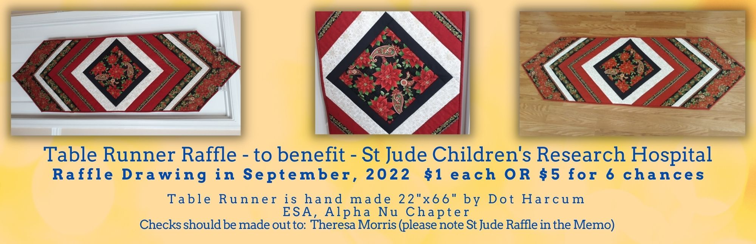
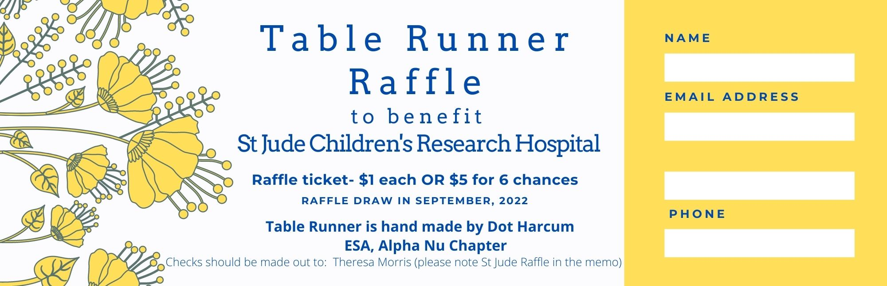

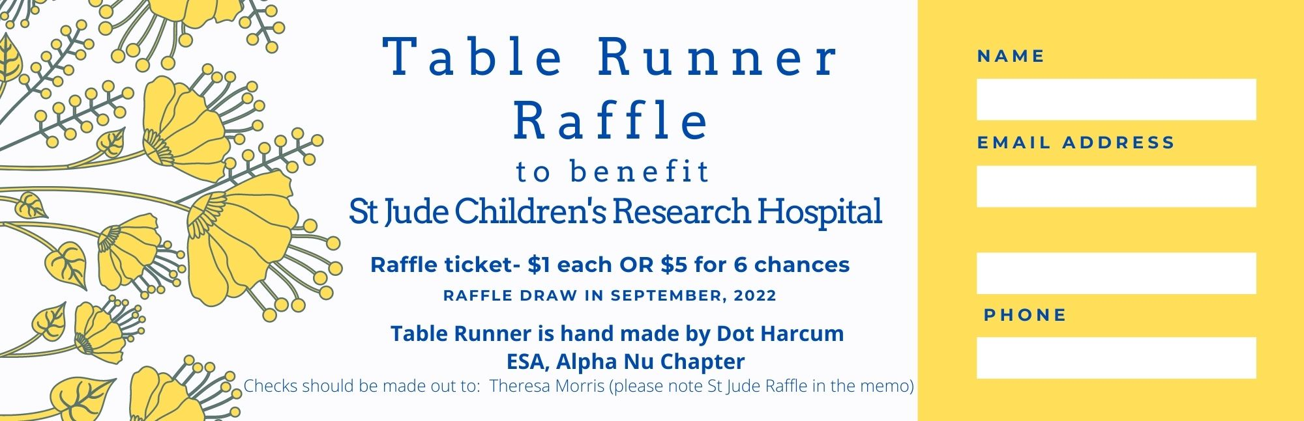

2022-23 VSC CHAPTER PRESIDENTS

CHAPTER NAME | PRESIDENT’S INFORMATION
Alpha Chi, #2055, Waynesboro | Brenda Bowersox  196 Mine Branch Road  Crimora, VA 24431  Brensox55@hotmail.com  540-430-0139
Alpha Delta, #4901, Richmond | Beth Sherron  13606 Quail Hollow Court  Midlothian, VA 23112  bethsherron@verizon.net  804-745-0705 (h)  804-513-3357 (c)
Alpha Nu, #5572, E-Chapter | Pat Holtsclaw  316 Cumbria St.  Gordonsville, VA 22942  holtsclawfamily@aol.com  540-406-5995 (h)  540-219-8665 (c)
Alpha Omega, #2060, Winchester | Laura Button-Cain  536 Bellview Avenue  Winchester, VA 22601  mslauramae@live.com  540-662-8441 (h)  540-247-9365 (c)
Beta Delta, #3793, Roanoke | Shelby Hodges  12 Meadow Circle  Daleville, VA 24083  Shelby.hodges@gmail.com  540-992-3974

Beta Kappa, #3721, Virginia Beach | Deana Renn  1212 Lakeford Place  Chesapeake, VA 23322  deanarenn@gmail.com  757-287-2143 (c)
Beta Omicron, #3740, Staunton | Jackie Nash  237 Taliaferro Drive  Churchville, VA 24421  Jnash1959@gmail.com  540-337-6079 (h)  540-292-0367 (c)
Beta Sigma, #4368, Richmond | Pam Cook  2350 New Market Rd.  Henrico, VA 23231  Gogopam1@gmail.com  804-312-7279 (c)
Beta Tau, #3953, Woodbridge | Sandy Reed  22 Dayton Circle  Fredericksburg, VA 22406  Reedsr2@gmail.com  540-373-4664 (h)  703-489-7442 (c)
Delta Kappa, #4727, Roanoke | Elaine Prillaman  5751 Lost Dr. SW  Roanoke, VA 24018  esprill@yahoo.com  540-774-6344 (h)  540-312-8396 (c)
Delta Rho, #4512, Front Royal | Debbie Langfitt  564 Lewis St.  Front Royal, VA 22630  deborahlangfitt@yahoo.com  540-636-2138 (h)  540-683-4963 (c)
Delta Sigma, #5364, Manassas | Sheen Childress  10812 Haggle Court  Manassas, VA 20112  sheenchildress@msn.com  703-257-7608 (h)  703-627-6587 (c)
Gamma Pi, #5491, Staunton | Brenda Orebaugh  1434 Terrace St.  Staunton, VA 24401  brendaorebaugh@gmail.com  540-290-3193 (c)
Sigma Chi, #5379, Roanoke | Jo Reedy  1834 Arlington Rd. SW  Roanoke, VA 24015  joreedy@yahoo.com  540-342-5287 (h)  540-529-1156 (c)
Theta Mu, #5307, Richmond | Nicole Lewis  7743 Balla Ct.  Henrico, VA 23228=-6343  Nicolelewis2@verizon.net  804-346-9484 (h)  804-928-7743 (c)  804-559-6386 (w)
Zeta Nu, #5506, Smith Mountain Lake | Tracie Ayers  876 Redbud Lane  Moneta, VA 24121  tracieayers@me.com  540-420-2482
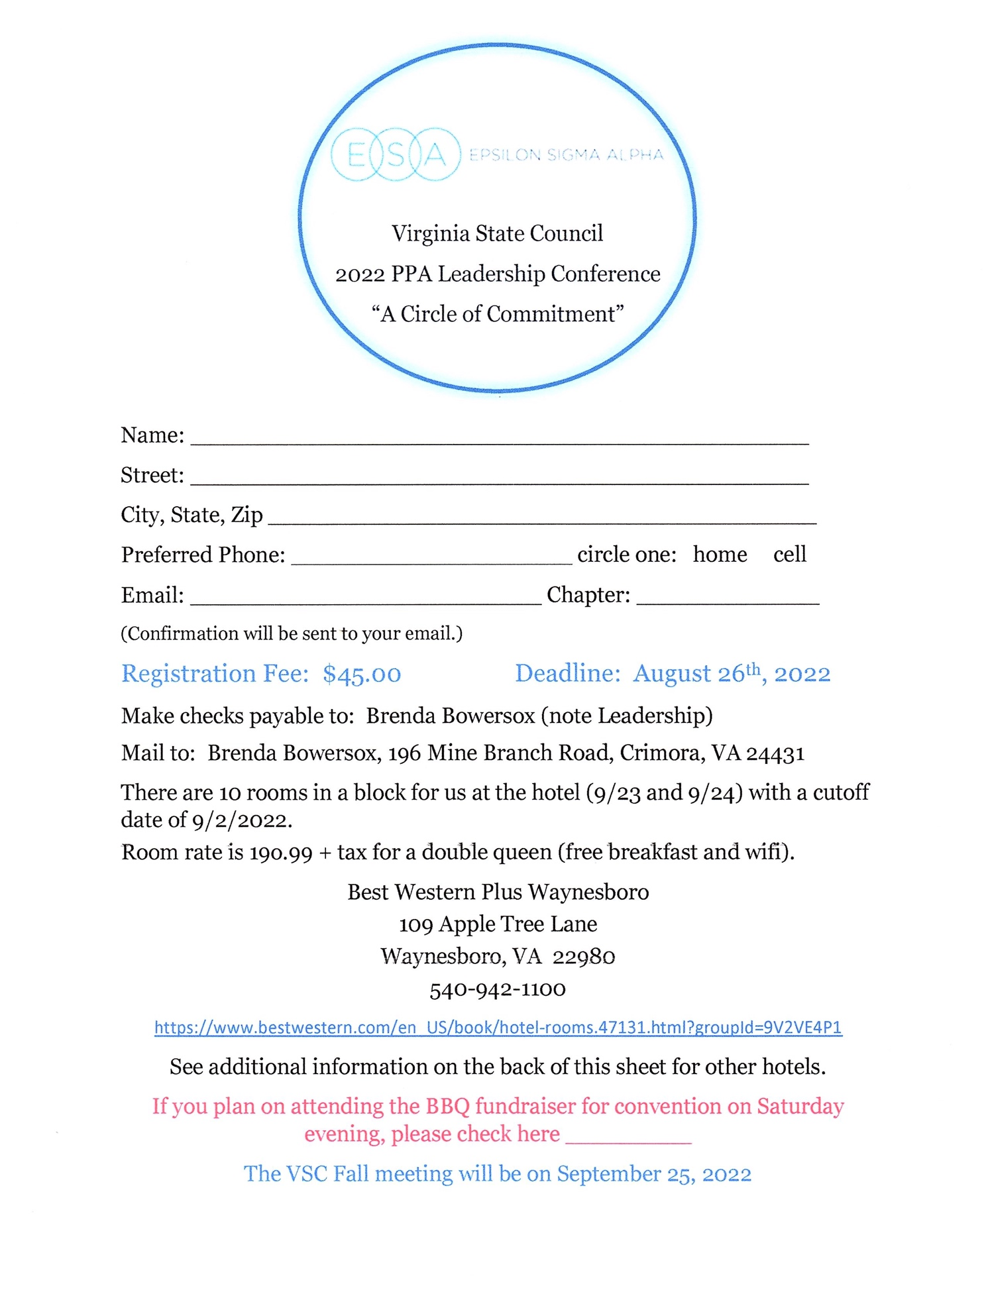

These room rates are as found on the individual hotels website for that weekend. They could change at any time.

Holiday Inn Express – Room Rate $243.00

https://www.ihg.com/holidayinnexpress/hotels/us/en/waynesboro/waybr/hoteldetail?cm_mmc=BingMaps-_-EX-_-US-_-WAYBR

Comfort Inn – Room Rate $200.00

https://www.choicehotels.com/virginia/waynesboro/comfort-innhotels/va376

Days Inn – Room Rate $124.99

https://www.wyndhamhotels.com/days-inn/waynesboro-virginia/days-innwaynesboro-va/overview

Super 8 – Room Rate $99.99

https://www.wyndhamhotels.com/super-8/waynesboro-virginia/super-8waynesboro/overview


