 The Circle

2022-23 VSC President’s Newsletter September 2022 Issue

DATES TO REMEMBER:

- September 17 – SEND COPIES OF REPORTS TO BE GIVEN AT THE VSC FALL COUNCIL MEETING TO BEVERLEY AND KATRINA.

- September 24 – VSC EXECUTIVE BOARD MEETING
8:15 a.m.

- September 24 – VSC Leadership Conference, Best Western, Waynesboro, VA
See schedule below.

- September 25 – VSC Fall Board Meeting, Best Western, Waynesboro, VA

8:45 a.m. – REGISTRATION
9:45 a.m. – CALL TO ORDER
Coffee/pastry provided.

- October 1 – VSC Chapter Dues (first half) due - $11.00 per chapter member; make checks payable to VSC ESA and give/mail them to Stephanie Hess

Bring to the VSC Fall Meeting and give to Stephanie if you haven’t already mailed.

- November 4-5 – SERC Conference, Renaissance Orlando Airport Hotel, Orlando, FL

- March 25, 2023 – VSC Spring Board Meeting, Vision of Hope United Methodist Church, Harrisonburg, VA

- May 19-21, 2023 – VSC Convention, The Hotel Madison, Harrisonburg, VA

From the President …

The PPA Leadership Conference and VSC Fall General Board Meeting is fast approaching and I sincerely hope that many, many of you are planning to attend.

It has been four months since many of us have seen one another, and this opportunity is the best one to relax, learn a little something, eat some good food, and get this next ESA year off to a great start in Virginia.

I want to thank all of you who sent notes of cheer during my COVID experience. With the exception of the ‘Covid Cough’ which seems to linger on, I am back to normal.

Joe, Amanda, and I spent last week in Emerald Isle, NC. The weather was beautiful (in the high 80s/low 90s). I ate too much, but the seafood is oh so good! It was a very relaxing week away from home doing absolutely nothing – well I did read 6 books but that’s my guilty pleasure anytime/anywhere.

From the VSC PPA Leadership Chairman … Brenda Bowersox

I am so excited that so many of you have registered for Leadership. Here is short agenda again so that you may make your final plans.

Leadership Registration: 9:00 AM
Leadership Starts: 10:00 AM
Lunch: 12:30 PM (about)
Leadership Resumes: 1:15 PM
Leadership Ends: 3:30 PM
PPA Meeting: 3:45 PM
BBQ Dinner: 6:00 PM

We will also have a little fun after the BBQ Dinner. This is Childhood Cancer month and as a way to contribute to that as well as ‘$50 for 50’ we will be playing Trivia. If you would like to play it is only a $5.00 contribution. Even if you would rather not play, we will still accept your donation. But, why not end the day with a little fun. I have the best Trivia team working on this (Beta Sigma) and Susan Caldwell will be accepting your contributions.

If you wish to write a check for the BBQ Dinner it should be made out to ‘2023 VSC Convention’.

Also, don’t forget the PPA Bazaar! It will be going in the morning, at lunch and probably during part of the evening.

Looking forward to seeing you soon!

Registration form and flyer attached.


This Photo by Unknown Author is licensed under CC BY

September 5 – Elaine Prillaman, Delta Kappa
September 12 – Vickie Brown, Sigma Chi
September 23 – Marie LaDuke, Beta Sigma
September 25 – Shelby Hodges, Beta Delta
September 26 – Sheila Levinson, Zeta Nu
September 30 – Judy Williams, Beta Sigma

Birthstones: Sapphire
Birth Flowers: Aster
Attributes: Hard working, health conscious, born artists, practical, loyal, and organized.

Circle of Grace

If something or someone has come into your life for which you are very thankful, or you see God’s grace in action - let others know about it.

God’s grace was certainly surrounding many of our ESA sisters/families as they have been traveling. Jimmy & Brenda B. went to Alaska – pictures were amazing and Mindy & John Boyd are currently touring several Scandinavian countries. Safe travels to All!

Several ESA members are dealing with personal issues they do not care to share at this time. When you go to bed tonight, please ask God to watch over and heal all those who are dealing with physical and mental health issues.

Beverley
Health Corner

As I said earlier, I ate too many fried things last week while at the beach. Back on the carb watch!

I did have my 6-month check-up and all my blood work looked good so that is a blessing. Just need to watch those calories and move more!

ESA FOUNDATION VOTE ….

All voting members of the ESA Foundation should have received an electronic ballot to vote on the bylaw revisions. These were discussed at IC and the voting closes at 11:00 p.m. MST on September 18. As VSC President, I will be casting our vote and since this is before our meeting I plan to vote in favor of these changes. If anyone has any concerns, please access the changes on the ESA Foundation website and let me know before September 18.

2022 SERC CONFERENCE ….

ESA Florida State Council is looking forward to seeing you and your membership at the 2022 SERC Convention November 4-5. Many of you have already registered, meeting the October 7, 2022 deadline. We hope many more of you will join us for what we expect to be a great time. It looks like President Terri is going to make sure we have a lot of FUN!!

In addition to the good times of convention ESA Florida State Council has arranged for more adventure.
The attachment below provides information on two unique experiences for you to choose from. Please note both of these tours are on November 4th. The deadline to sign up for the excursion of your choice is October 7th.

Please send this information to your state membership so that the members can get their reservations in by the deadline of October 7th. I

Should you have any questions please reach out to Karlene Beville at bevillek@gmail.com
407-414-3462 or
Joy Lehnert
at joy.lehnert@yahoo.com
402-690-7720.

See you soon!

Thank you.

Verna Cornell, Co-Chair
Christine Bishop, Co-Chair
Joy Lehnert, Secretary/Treasurer
2022 SERC Convention

Please see attachment!

MESSAGE FROM IC NOMINATING COMMITTEE … BEV SCOTT
Congratulations to Bev Scott on her position as a member of the IC Nominating Committee.

Attached are the qualifications and forms to be used by anyone who is interested in serving on the 2023-24 IC Elected Board.

2025 IC CONVENTION

As you know by now, SERC is hosting the 2025 IC Convention. We have suggested North Carolina as a possible destination. Our IC Hotel Contracts Committee has passed information to a professional agent to start the process of finding a suitable location. I hope to have news of their findings by the time we go to Orlando for the 2022 SERC Conference. The date is tentatively July 13-20, 2025.

We would like to have a planning meeting in Orlando. To help facilitate that meeting, I would ask each SERC State to choose a spokesperson to attend that meeting. This person will be the liaison between their state and the Convention Executive Committee. Since we do not know the location yet, it will be a little difficult to pick a theme, colors, and decorations, but please put on your thinking caps and bring ideas from your states to Orlando so that we can get started with all the plans to make 2025 IC successful and fun.

Each State President is responsible for getting this information to their council members before we go to Orlando.
Looking forward to seeing many of you in Orlando.

Make A Great Day,
Mary P. Smith & Denise Holdaway, Convention Co-Chairs

NOTE FROM PRESIDENT … If someone would like to volunteer to be this liaison, please let me know asap. If no one volunteers, I will be happy to represent Virginia at this meeting.

INSIDE THE CIRCLE

- LUCKY NUMBERS CONTRIBUTIONS FOR THE VSC FALL COUNCIL MEETING!
The Finance Committee has come up with the theme “Lucky Numbers Craft Fair” for the VSC Fall Leadership donations. So, each chapter bring something you made or something someone else made for the ways & means event.
Note from President: If no one from your chapter will be in attendance, please consider sending something by another chapter. Right now, this along with dues, is the only money- making project supporting the Virginia State Council and your help would be greatly appreciated.

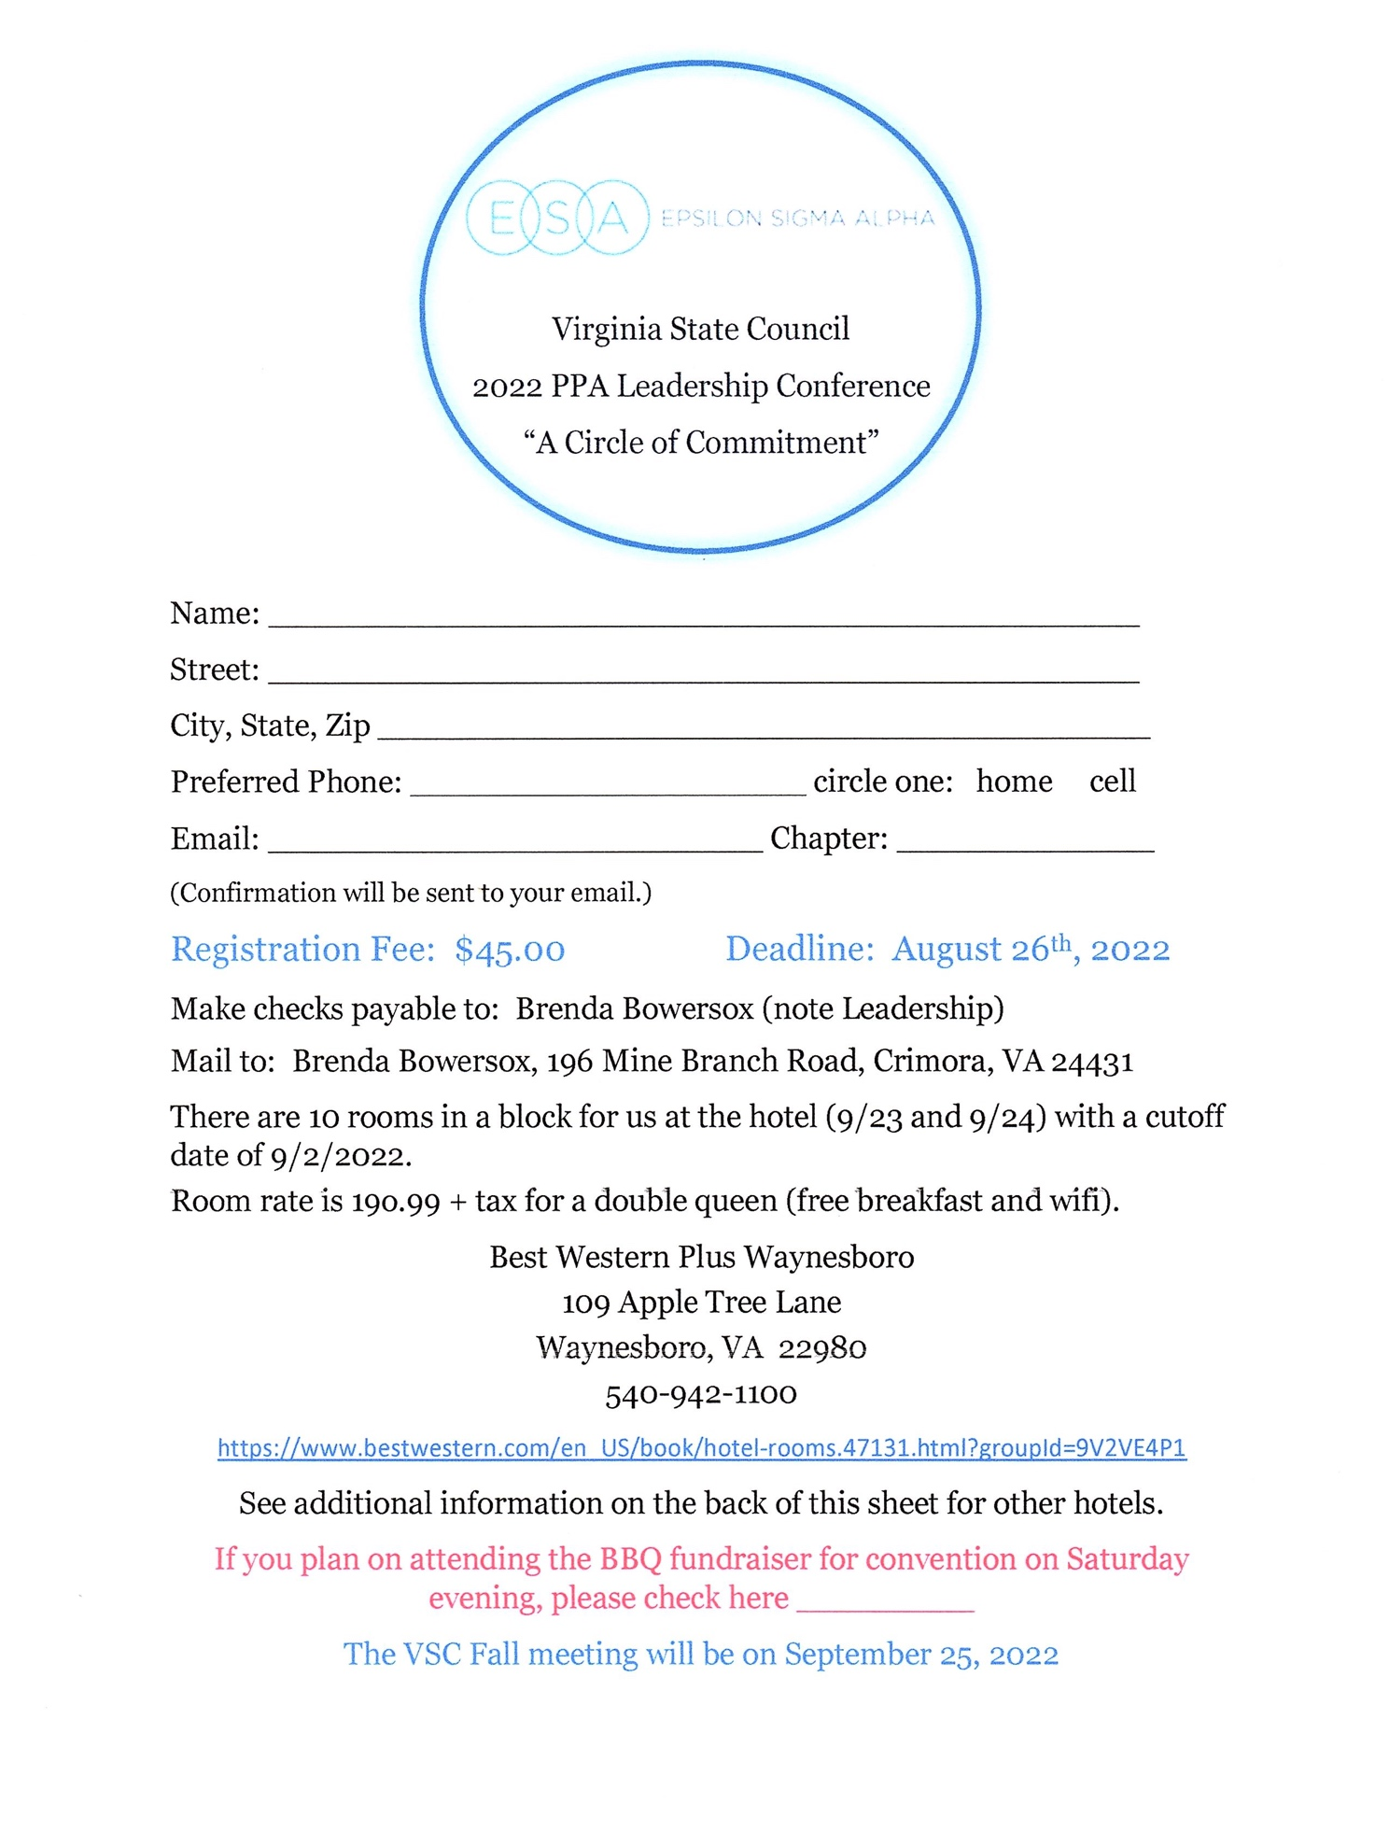

These room rates are as found on the individual hotels website for that weekend. They could change at any time.

Holiday Inn Express – Room Rate $243.00

https://www.ihg.com/holidayinnexpress/hotels/us/en/waynesboro/waybr/hoteldetail?cm_mmc=BingMaps-_-EX-_-US-_-WAYBR

Comfort Inn – Room Rate $200.00

https://www.choicehotels.com/virginia/waynesboro/comfort-innhotels/va376

Days Inn – Room Rate $124.99

https://www.wyndhamhotels.com/days-inn/waynesboro-virginia/days-innwaynesboro-va/overview

Super 8 – Room Rate $99.99

https://www.wyndhamhotels.com/super-8/waynesboro-virginia/super-8waynesboro/overview
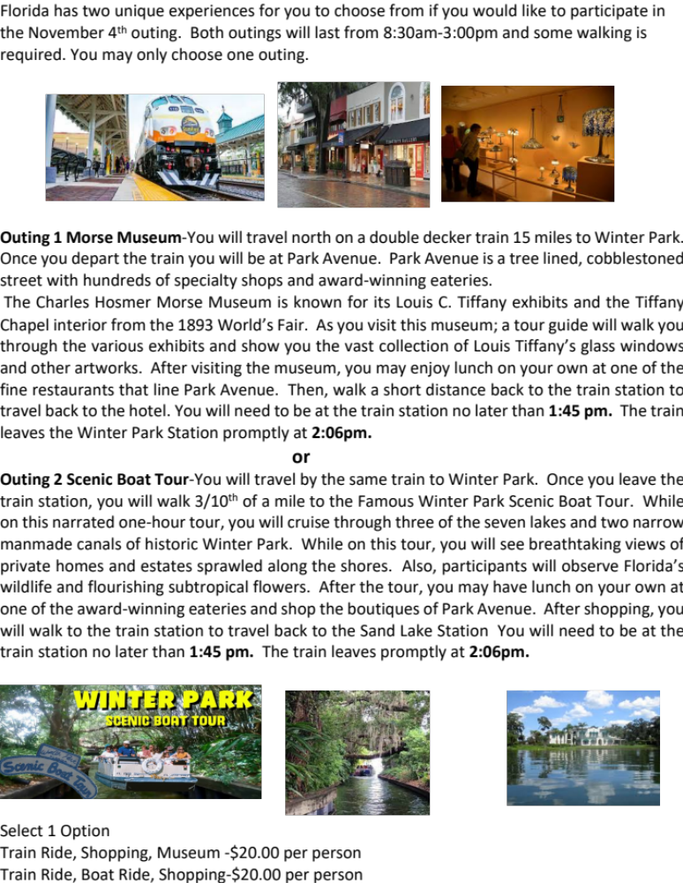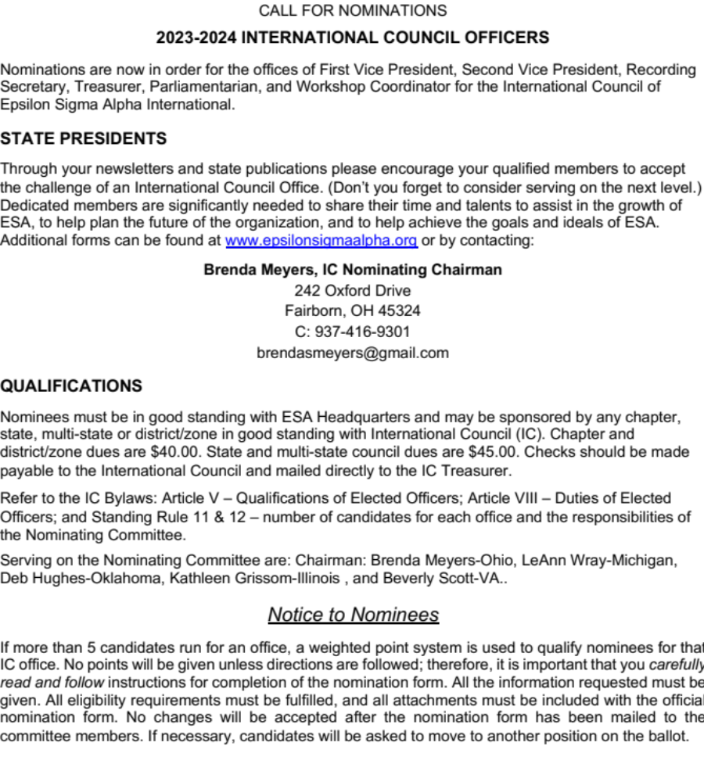

- Please type or print the form legibly.
- List the year(s) served as President and each elected and appointed office.
Example: President 2010-2011; First Vice President 2009-2010; Second Vice President 2008-2009; Recording Secretary 2007-2008; etc. Offices must either be elected or appointed and may not be listed twice.
- If an office has several responsibilities. list only the elected office.
Example: If the Vice President, because of the elected office, is also the Membership Chairman, only the Elected office may be given – the chairmanship should not be listed. This may also apply for Junior Past President and Disaster Fund Chairman.
- If you were appointed to complete an office for an unexpired term you may list this office if the term of office is for three (3) months or more.
- Committee appointments should be for the required term of office of three months or more. Do not list special appointments for special events. Appointments must be made by the President of the referenced council.
- Do not include any recognition, such as, Outstanding Woman/Pledge etc.
- Do not include qualifications on a separate sheet of paper. All qualifications must be included on the nomination form.
- The Nomination Form must be postmarked no later than November 15, 2022. Mail or email the form with all attachments (sponsoring letter, letter of nominee’s acceptance, and photo (5X7 if printed photo - .jpg if sent via email) to Brenda Meyers, 242 Oxford Dr, Fairborn, OH 45324 or email brendasmeyers@gmail.com. Cell Phone-937-416-9301
- The signature of either your chapter or state/multi-state president is required; however, the contact information is needed for both.
- Address all questions concerning the listing of qualifications or other matters regarding nominations to Brenda Meyers, IC Nominations Chairman.

Nominee |  |  |  |  |  |  | Member Number:
Phone |  |  | Email
Address |  |  |  | City |  |  |  |  |  | State |  | Zip
Employer |  |  |  | Occupation
Chapter Name and Number
City |  |  |  |  |  | State
Nomination for the office of
Second Choice of office
(It is recommended that nominee have previous experience on the IC Executive Board or have a strong accounting background before being nominated for IC Treasurer)

Background Information
QUESTIONS | YES | NO
Does nominee have a working knowledge of computers?
Does nominee have working knowledge of bookkeeping/QuickBooks?
Does nominee have knowledge of parliamentary procedure and Roberts’ Rules of Order Newly Revised?
QUESTION | # OF YEARS
How many years of ESA service does the nominee have?

Eligibility Requirements
QUESTIONS | YES | NO
Nominee has been an active member for the past three years?
Nominee has held the office of Chapter and State or Multi-State Council President?
Nominee’s acceptance letter is attached?
Sponsor letter from Chapter and/or State/Multi-State is attached?
5 x 7 color photo or .jpg color photo of nominee is included?
Nominee’s chapter’s dues have been paid to the International Council?
Nominee’s state’s dues have been paid to the International Council?
Nominee’s individual dues have been paid to ESA Headquarters?
All dues have been verified as paid by Nominating Committee Chairman?
QUESTIONS | # OF YEARS
Number of State Conventions nominee has attended?
Number of International Conventions nominee has attended?

INTERNATONAL COUNCIL OFFICES HELD (list years)
Second Vice President |  |  |  | Recording Secretary
Treasurer |  |  |  | Parliamentarian
Workshop Coordinator |  |  |  | Appointed Chairs (include Corresponding Secretary)
MULTI-STATE COUNCIL OFFICES
ELECTED OFFICES
APPOINTED OFFICES
STATE COUNCIL OFFICES HELD (list years)
President |  |  |  | First Vice President
Second Vice President |  |  |  | Recording Secretary
Corresponding Secretary |  |  |  | Treasurer
Parliamentarian |  |  |  | Junior Past President
Other Elected Offices
Appointed Chairs (include offices of past presidents’ auxiliary)

In 50 words or less state why you would like to be an IC officer, what your objectives would be and how you plan to accomplish those objectives:
<Note: due to Journey space constraints quote will be edited if more than 50 words are submitted>

Sponsor Signatures
Chapter President’s Name (printed or typed) |  |  |  |  |  |  |  | State or Multi-State President’s Name (printed or typed)
Chapter President’s Signature |  |  |  |  |  |  |  | State or Multi-State President’s Signature
Address |  |  |  |  |  |  |  | Address
City |  |  | St |  | Zip |  |  |  | City |  |  | St |  | Zip

