 The Circle

2022-23 VSC President’s Newsletter November 2022 Issue

DATES TO REMEMBER:

- February 23-26, 2023 - ESA Leadership Conference, Denver, CO

- March 25, 2023 – VSC Spring Board Meeting, Vision of Hope United Methodist Church, Harrisonburg, VA

- May 19-21, 2023 – VSC Convention, The Hotel Madison, Harrisonburg, VA “Turning the Pages with ESA”

From the President …

It has been a LONG time since the last issue of “The Circle” was published – September no less - lots has happened since then!

We had a fantastic time at the VSC Fall Leadership and Council Meeting in October. Again, many thanks to Brenda Bowersox for all her planning. It was so gratifying to see that everyone opted to join us for our ‘2023 VSC Convention Fund Raising Dinner’ on Saturday night and most stayed and played Trivia to benefit St. Jude. Your participation in both efforts is greatly appreciated.

My hubby, Joe, celebrated his 75th Birthday in October with close friends and family dining at our house.

I started another Bible Study at church entitled, “The Names of God”… it is really good so if you have the opportunity to catch this one, please do. I have learned a LOT!

Now … what can I say about SERC? The only downside was the long care ride to and from Orlando. I know I will not drive it again but thanks to God and all the angels watching over us, everyone got there and back home safely.

The Renaissance Hotel was really very nice. The food was tasty and I tried a French Martini (okay …. Really two!) and it was soooo good. Those Florida ladies and men were extremely organized and you know how I love a plan in motion. Kudos to all of them on the arrangements and tours! Brenda B., Bev S., Brenda O., and I went on the lake tour and saw some of the hugest, most expensive houses I have ever seen. The weather in Orlando was in the mid to upper 80’s which suited me to a tee.

Special thanks to our Beta Sigma sisters (Susan C., Pam C., Marie L., and Lynne R.) who offered their condo for our ‘state meal/meeting’. All eleven (11) of us were able to attend, eat, drink, laugh, cry, and overall had an awesome evening.

Start planning now to attend SERC in 2023. It will be at the Embassy Suites in Pooler (Savannah), GA.

Thank you once again for allowing me to represent Virginia at this conference.

I am attaching a list of the newly installed/appointed SERC officers, which you may choose to print out and add to your yearbook or access through the SERC website.

Message from …SERC Director – Brenda Bowersox

The 2022 SERC Conference was held in Orlando, Florida, Nov. 4th – 5th.

The Florida delegation did a wonderful job with the weekend. We were surrounded by flamingos all weekend.

During the business meeting there was great emphasis put on the new budget.

The budget committee with the Executive Board put a lot of thought in how to make cuts to the budget. Each line item was thought out carefully. The amount for travel to state conventions was cut in half.

If we want to continue to have
representatives to our states we will need to consider increases for the state dues and of course our chapter donations. No changes were made at conference as that requires some by-law changes. We should expect to see several changes to the by-laws at next year’s conference to help with the deficit.

In our ever-changing world the considerations shouldn’t be a surprise. Please take a look at your budget and see if your chapter may be able to send a little extra as your chapter donation.

I will make sure that there is a chapter donation form included in the next Lamplighter. The SERC website is down at the moment.

Message from …2023 VSC Convention Chairman – Brenda Bowersox

The convention committee would like to thank all of those who supported our BBQ dinner after Leadership. Special thanks to those who provided the food and all the essentials. We hope that you enjoyed it as much as we enjoyed hosting you. (Jimmy’s head was a little big for a couple days 😊 ).

The registration form has been sent to the team to be added to the VSC website. It is a little early yet but we will have more info after the new year.

We look forward to spending time with you in May.

Message from …Disaster Fund Chair – Mindy Boyd

Reminder to all that I’d like to get at least $5.00 per member for our fund and remember this fund is for members in ESA that have experienced a natural disaster. What a better way to help our own membership.

Remember I’ll have a drawing for all those that contribute at convention for $100, $50, and $25!

Also, for anyone thinking of going to IC convention in July 2023, we need to consider participating in the lip- syncing contest. It was so much fun last year and I know with Virginia’s talent we could overtake all! So, starting thinking and planning now!

Respectfully; Mindy

Message from …Hope for Heroes Chair– Bev Scott


Good morning ESAers,
As your ESA Hope for Heroes appointee for 2022-23, I would like to clear up a few details from the Fall meeting report and give you some additional info.

First and most important is I am afraid I gave the impression that the only way to donate to Tunnels to Towers was to make a $132 donation. That is definitely NOT the case…any amount that you or your chapter can give will help the Gold Star Families and the catastrophically injured soldiers. As with most fund-raising foundations, the Tunnels to Towers promotes signing up to give a manageable $11.00 a month. You can sign up to do it monthly on the donation form. The $132.00 even in Bev math is the total you would give in a year, so you can do it either way.

T2T is a 501(c)(3) tax exempt organization. Their number is on the form. Another great thing about the donation form is that you can make your donation “in Honor of” or “In Memory of” and add the Acknowledgement of Dedication to be sent to a third person. As an example of this, an ESA member made a donation in Memory of her Dad, and had an acknowledgement sent to her Mom. I made a donation in Honor of my daughter’s birthday by phone (717) 987-1931, and she received an email immediately, and I did as well as a receipt for my donation.

Lastly, I always check how much of any donation goes directly to the projects of the organization. In the case of Tunnel to Towers Foundation 95% goes directly to the programs and services with 3% going to fundraising and only 2% goes to manage the Foundation.

Most of us are retired, all of us face the high cost of gas and groceries! Asking you to add a new project when we still want to help the children at St. Jude and Easter Seals is a BIG ASK. That is why I want to re-state that ANY amount will be beneficial.

I think almost everyone stood when asked if they had a relative that served or was serving in the military (I left out siblings, sorry), so maybe you could think of a donation/Christmas remembrance to that person.

Note: Donation form attached.



HAPPY BELATED BIRTHDAY TO OUR OCTOBER AND EARLY NOVEMBER MEMBERS AND BEST WISHES TO THOSE CELEBRATING MID TO LATE NOVEMBER!

October 5 – Nancy Barnes, Delta Rho
October 5 – Joan Dodson, Alpha Omega
October 8 – Peggy Thompson, Delta Rho
October 10 – Larry James, Beta Kappa
October 10 – Joy Mills, Beta Kappa
October 12 – Tracie Ayers, Zeta Nu
October 12 – Mindy Boyd, Alpha Nu
October 17 – Sandy Reed, Beta Tau
October 26 – Gwen Conner, Alpha Chi
October 29 – Ruth Clatterbuck, Delta Rho
October 31 – Stephanie Hess, Zeta Nu
October 31 – Elaine Hilton, Beta Kappa

November 6 – Laura Button-Cain, Alpha
Omega
November 16 – Ann Taylor, Alpha Omega
November 18 – Nancy Lemons, Sigma Chi
November 20 – Julie Vance, Beta Delta
November 22 – Polly Look, Alpha Omega
November 23 – Pam Cook Smith, Beta Sigma
November 27 – Kaye Martin, Beta Kappa
November 29 – Ginger Hodges, Beta Delta

Circle of Grace

If something or someone has come into your life for which you are very thankful, or you see God’s grace in action - let others know about it.

Brenda O. and I truly felt the hand of God and guardian angels on our trip back from Orlando.

First, we took an exit off I-77 in SC to grab something to eat and use the bathroom facilities. The Wendy’s we went to first was closed, except for drive-thru, so we had to get back in the car and go to the McDonald’s down the road. We were trying to make it back to Virginia in one day and were right on track so this delay was not welcomed. After getting back on I-77, within 10 minutes traffic came to a stop. We sat for over 2 hours. We found out from people who were walking ahead to see what had happened that there was an 11-car pile-up just ahead of us. You have to wonder if that unwelcomed delay was all in God’s plan or just a fluke! When traffic finally started moving, we got off the next exit and spent the night in SC.

The next morning, we hit the road relatively early (after the thick fog had lifted) and were motoring along when between Blacksburg and Salem I went to pass a tractor/trailer and he came over into my lane without any warning or signal. We were so fortunate that on this stretch there was no guard rail or we would have been pushed right into it. I was able to gain control of the car and get off the road far enough to the left to avoid being hit. Our next stop was the REST AREA!!!

So, you can say these are coincidences or a “God Wink” but whatever you believe I choose to just be grateful and thankful!

Beverley



ESA IS GOING GREEN …

During the SERC conference, Charlotte Carloni, expanded on what ESA Headquarters is doing to save time and expenses in the future.

- Auto Billing – You will receive a notification on the 1st of the month in which your International Due are due.
- Paperless billing reminder.
- Virtual membership cards are available through the My Account portal on the ESA International website (epsilonsigmaalpha.org).
2025 IC Convention??? …

Mary Smith and Denise Holdaway, 2025 IC Convention Co-chairs, held a brief meeting at SERC. A couple of take aways …

*The convention WILL NOT be in Wilmington, DE due to hotel pricing issues.

*The Hotel Contracts Committee is actively looking for a place to host this convention.

*Mindy Boyd volunteered to be the liaison from Virginia for all things concerning this convention. Thank you, Mindy!

NEXT ISSUE OF ‘THE CIRCLE’

The holidays are fast approaching. My wish for you all is that you find joy with those you love and in making a difference in the lives of others.

Deadline for the next issue is January 1, 2023.

Photos were taken at the Welcome/Mixer on Friday evening at SERC and each person attending was given a copy of their State photo… WHAT A GREAT IDEA!

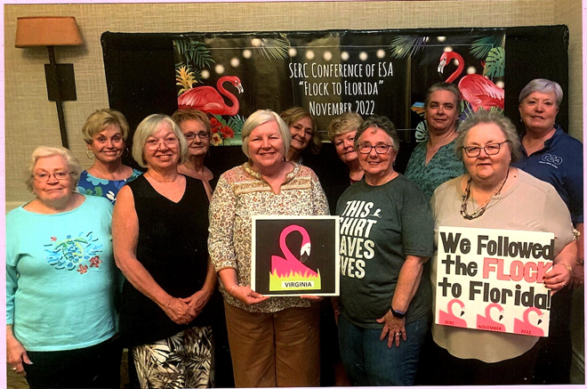

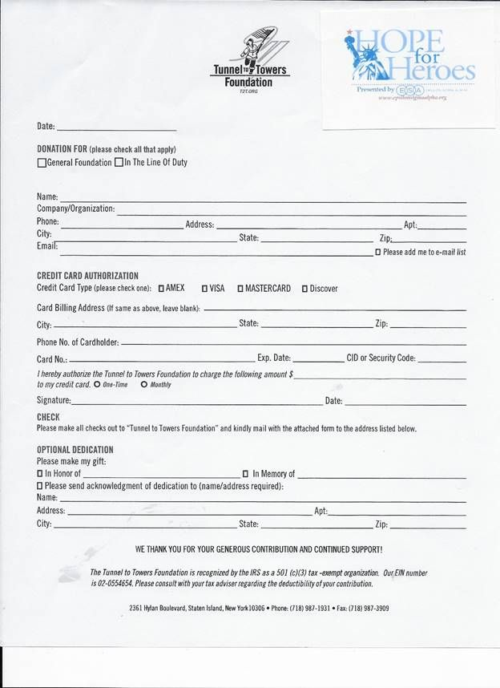
SOUTHEASTERN REGIONAL COUNCIL EXECUTIVE BOARD
2022-23

PRESIDENT
Theda Hall
4400 Tahoe Circle Dr
Springdale, AR 72762-7404
Cell: 479-899-3044
tlhent@aol.com

FIRST VICE PRESIDENT
Laura Gnewuch
2313 Grande Valley Circle
Cary, NC 27513
Cell: 919-345-4566
Laura.gnewuch@gmail.com

SECOND VICE PRESIDENT
Tammy Gregg
1328 Hunts Bridge Road
Easley, SC 29640
Cell: 864-483-1538
Tammyjo21@yahoo.com

RECORDING SECRETARY
Kelli Thornberry
1118 East Burnett Ave
Louisville, KY 40217
Cell: 502-54-8197
kjthornberry@yahoo.com

CORRESPONDING SECRETARY
Meghan Good
1600 Phyllis Street Apt 1005
Bentonville, AR 72712
Cell: 479-270-3685
Missmegs89@gmail.com

TREASURER
Trish Villines
1877 May Lane
Harrison, AR 72601
Cell: 501-804-7409
t.villines@icloud.com

PARLIAMENTARIAN
Lauren Ryan
202 Chateau Place
Chapel Hill, NC 27516
Cell: 607-351-5470 laurengeryan@gmail.com

JR PAST PRESIDENT
Terri Sayre
2200 Ormond Blvd
Destrehan, LA 70047
Cell: 504-231-6145
tlsayre@cox.net

SOUTHEASTERN REGIONAL COUNCIL APPOINTED BOARD
2022-23

ASSOCIATION OF THE ARTS
Kim New
3873 Liberty Road
Villa Rica, GA 30180
Cell: 770-757-6022 kimnew@bellsouth.net

Susan Garner
2015 Daniel Road
Villa Rica, GA 30180
Cell: 770-856-7798 Stg2015@bellsouth.net

AUDIO VISUAL CHAIR
Brandy Whittaker
1303 Cherry Street
Burlington, NC 27215
Cell: 336-263-1492
Bboone4@elone.edu

AWARDS CHAIR
Anita Kay Hilburn
233 Sugar Creek Loop
Minden, LA 71055
Cell: 318-773-9228 Anita.hilburn@gmail.com

AUDITOR
Brenda West
317 Bird Circle
Greenville, TN 37743
Cell: 423-608-0123 brendawest@aol.com

BYLAWS COMMITTEE CHAIR
Lauren Ryan
202 Chateau Place
Chapel Hill, NC 27516
Cell: 67-351-5470 laurengeryan@gmail.com

BYLAWS COMMITTEE
Kim New
3873 Liberty Road
Villa Rica, GA 30180
Cell: 770-757-6022 kimnew@bellsouth.net

Diana Cohen
4001 Delaware Drive
Lagrange, KY 40031
Cell: 502-667-0232 ladydibari@gmail.com

CHAPLAIN
Sandy Fletcher
14366 Route E
Pineville, MO 64856
Cell: 479-381-0198 skgood66@yahoo.com

BUDGET COMMITTEE CHAIR
Trish Villines
1877 May Lane
Harrison, AR 72601
Cell: 501-804-7409 t.villines@icloud.net

BUDGET COMMITTEE
Laura Gnewuch
2313 Grande Valley Circle
Cary, NC 27513
Cell: 919-345-4566 Laura.gnewuch@gmail.com

Betty Boullion
728 West Gloria Switch Rd, Lot 49 Lafayette, LA 70507
Cell: 337-230-4295 Betty.boullion@yahoo.com

Jennifer Gailey
708 Bob White Ct
Mount Juliet, TN
Cell: 615-414-5519 Thackerchic4@gmail.com

EASTERSEALS CHAIR
Terry Holifield
135 Christian Lane
Summerville, SC 29486
Cell: 843-870-7678 doublehh@homesc.com

FINANCE COMMITTEE CO-CHAIRS
Dawn Middleton
P O Box 111
Summit, MS 39666
Cell: 601-810-6508 Dawnmiddleton1@gmail.com

Debbie Willoughby
22000 Effingham Circle
Raleigh, NC 27615-3826
Cell: 919-219-5866 deborahw@nettapp.com

Casey Hoffman
930 North Street
McComb, MS 39648
Cell: 601-551-9525 kchoffman@hotmail.com

FLAG CEREMONY/OPEN & CLOSE

Tammy Akines
10504 State Hwy 54
East Star City, AR 71667
Cell: 870-370-0923 tsakines@yahoo.com

HOPE FOR HEROES
Sondra Kucklick
117 Messina Street
Moncks Corner, SC 29461
Cell: 843-834-1228 Lefsan124@gmail.com

HOTEL CONTRACTS CHAIR
Betty Keeton
305 Freada Drive
Florence, AL 35630
Cell: 256-710-4558 Betty8142@comcast.net

HOTEL CONTRACTS COMMITTEE
Rhonda Coy
317 Country Club Drive
Oldsmar, FL 34677
Home: 813-416-3577
rscoy@yahoo.com

Joy Lynn Tynes
180 Lucky Drive
Marietta, GA 30068
Cell: 400-660-0126 cjtynes@bellsouth.net

Wanda Ferris
23095 Arcwood Drive
Denham Springs, LA 70726
Cell: 334-324-2285
wlferris@att.net

PRESIDENTIAL ADVISOR
Mary P Smith
400 Newcastleton Drive
Wilmington, NC 28412
Cell: 336-254-5655 Mph.smith@yahoo.com

Judy Tomlinson
952 Paul Drive
Conway, AR 72034
Cell: 870-918-4982 Judy.tomlinson@conwaycorp.net

Vicky Jones
664 Grigsby Lane
Cadiz, KY 42211
Cell: 270-836-4804 Vickyjones325@bellsouth.net

INSTALLING OFFICER
Judy Tomlinson
952 Paul Drive
Conway, AR 72034
Cell: 870-918-4892 Judy.tomlinson@conwaycorp.net

NOMINATING COMMITTEE CHAIR
Laura Gnewuch
2313 Grande Valley Circle
Cary, NC 27513
Cell: 919-345-4566 Laura.gnewuch@gmail.com

NOMINATING COMMITTEE
Trudie Myers
1472 E. Monopoly Loop
Inverness, FL 34453
Cell: 605-881-1941 Tmyers53@tampabay.rr.com

Melinda G Boyd (Mindy)
13131 Lady Ashley Road
Midlothian, VA 23114
Cell: 804-869-4820 mindyboyd@verizon.net

Anna Lifsey
117 Kentwood Drive
Carencro, LA 70520
Cell: 337-344-6043
lmhtb@cox.net
ST JUDE COORDINATOR - SR
Anita K Hilburn
233 Sugar Creek Loop
Minden, LA 71055
Cell: 318-773-9228 Anita.hilburn@gmail.com

ST JUDE COORDINATOR - JR
Sandy Weston
P O Box 1123
Heflin, AL 36264
Cell: 256-310-3013 Spw2224@gmail.com

WEBMASTER
Vicky Jones
664 Grigsby Lane
Cadiz, KY 42211
Cell: 270-836-4804 Vickyjones325@bellsouth.net

SERCH EDITOR
Sarah Fletcher
550 Sorrento Drive
Centerton, AR 72719
Cell: 479-899-1321 Fletchersm27@gmail.com

SERCHETTE PRESIDENT
Rhonda Coy
317 Country Club Drive
Oldsmar, FL 34577
Cell: 813-746-3577
rscoy@yahoo.com

2023 CONFERENCE CO-CHAIRS
Romanda Talley
202 Cardinal Street
Pooler, GA 31322
Cell: 912-441-1843 romandatally@aol.com

Susan Knudson
3926 Birdie Drive
Douglasville, GA 30134
Cell: 770-949-1085 Knudson4070@comcast.net

BUTTERFLY MEMORIES(SCRAPBOOK)

Linda Cotterman
1802 Woolsey Avenue
Fayetteville, AR 72703
Cell: 479-387-6883
lpcott@cox.net

Brianne Wohlford
715 Dyer Street
Springdale, AR 72762
Cell: 479-249-3334 Briannewolford@yahoo.com

Patti Wohlford
621 Maple Street
Springdale, AR 72764
Cell: 479-463-0790 pwohlford@starfishnw.org

